

Bachelor of Computer Applications
Semester – V
Deep Learning
Assignment No.: 3
Title: Comparison of Deep Learning Architectures

Submitted By
Name: Adarsh Kasaudhan
Reg. No.:2411021240076
Date:31-08-2026

Submitted To:
Faculty Name: Nagasri P

Department of Computer Application
Alliance University
Chandapura - Anekal Main Road, Anekal
Bengaluru – 562106

Introduction
Deep Learning is a branch of Artificial Intelligence and Machine Learning that tries to make computers learn the way the human brain works. It uses something called artificial neural networks, which are made up of layers of small units called neurons, just like our brain has neurons connected to each other. These networks are called “deep” because they have many layers stacked one after another, and each layer learns to understand the data a little better than the layer before it.
In simple words, deep learning takes in raw data such as numbers, images, text, or sound, and passes it through many layers of calculations so that the computer can automatically find patterns in it. This is different from traditional programming where a human must manually tell the computer what rules to follow. In deep learning, the model learns the rules on its own by looking at large amounts of example data. This is why deep learning is used in things like face unlock on our phones, voice assistants like Siri and Alexa, self-driving cars, spam email detection, and even recommendation systems on Netflix and YouTube.
Now the question is, why do we need different types of neural network architectures instead of just one single model for everything? The answer is that different kinds of data need to be handled in different ways. For example, a simple table of numbers like student marks or loan details is different from an image, and an image is very different from a sentence of text where the order of words matters.
A basic Feedforward Neural Network (FNN) works well for simple structured data, but it is not efficient when the input is a large image, because it does not understand spatial patterns like edges or shapes. This is where Convolutional Neural Networks (CNN) come in, since they are specially designed to scan images and pick out visual features. Similarly, when the data comes in a sequence, like a sentence, speech, or stock prices changing over time, we need a network that can remember previous information. This is exactly what a Recurrent Neural Network (RNN) is built for, since it has a kind of memory that carries information from one step to the next.
This is why in real-world applications, choosing the right deep learning architecture for the right type of problem is very important. In this project, we will study FNN, CNN, and RNN in detail, understand their working, compare them, and look at where each of them is applied in daily life.

Task 1: Study of Architectures

3.1 Feedforward Neural Network (FNN)

Definition
A Feedforward Neural Network (FNN) is the most basic type of artificial neural network. In this network, information moves only in one direction, from the input layer, through one or more hidden layers, and finally to the output layer. There is no loop or cycle anywhere in the network, which means the data never moves backward. This is why it is called “feedforward.”

Architecture Explanation
An FNN is made up of three main types of layers. The input layer receives the raw data, for example marks of a student or details of a loan applicant. The hidden layer or layers process this data using weights, biases, and activation functions to find patterns. The output layer gives the final result, such as a prediction or a classification. Every neuron in one layer is usually connected to every neuron in the next layer, which is called a fully connected or dense layer.

Working Process
When data enters the network, each connection between neurons has a weight attached to it. The input value is multiplied by the weight, a bias is added, and the result is passed through an activation function like ReLU or Sigmoid. This process happens layer by layer until the output layer produces the final answer. During training, the network compares its output with the actual correct answer, calculates the error, and then adjusts the weights using a method called backpropagation so that the next prediction is more accurate.

Advantages & Limitations
- Advantage: Simple to design, understand, and implement.
- Advantage: Works well for structured, tabular data with clear input features.
- Advantage: Faster to train compared to CNN and RNN.
- Limitation: Cannot understand spatial patterns, so it performs poorly on images.
- Limitation: Has no memory, so it cannot handle sequential or time-based data.
- Limitation: Needs a large number of connections for big inputs, which can slow it down.

3.2 Convolutional Neural Network (CNN)

Layers of CNN (Convolution, ReLU, Pooling, Fully Connected)
A Convolutional Neural Network (CNN) is mainly used for image-related data and is built using a special combination of layers. The Convolution layer applies small filters, also called kernels, that slide over the image to detect basic features like edges, corners, and textures. After convolution, the ReLU (Rectified Linear Unit) activation function is applied, which removes negative values and helps the network learn faster and avoid unnecessary complexity. Next comes the Pooling layer, usually Max Pooling, which reduces the size of the data while keeping the important features, making the network faster and less likely to overfit. Finally, after several rounds of convolution and pooling, the data is flattened and passed into a Fully Connected layer, which works like a normal FNN and gives the final classification or prediction.

Working
When an image is given as input, the CNN does not look at the whole picture at once. Instead, small filters move across the image bit by bit, capturing simple features in the early layers, such as edges and colours. As the image passes through deeper layers, the network starts recognising more complex patterns like shapes, and eventually whole objects such as a face or a car. This layer-by-layer feature extraction is what makes CNNs so powerful for image and video related tasks.

Advantages & Limitations
- Advantage: Automatically extracts features from images without manual effort.
- Advantage: Very accurate for image classification, object detection, and face recognition.
- Advantage: Pooling layers reduce computation and control overfitting.
- Limitation: Requires a large amount of labelled image data to train well.
- Limitation: Computationally expensive and needs strong hardware like GPUs.
- Limitation: Not naturally suited for sequential data like text or speech.

3.3 Recurrent Neural Network (RNN)

Sequential Processing
A Recurrent Neural Network (RNN) is designed for data that comes in a sequence, where the order of information matters. Unlike FNN and CNN, an RNN does not look at the entire input at once. Instead, it processes the data one step at a time, for example one word at a time in a sentence, or one time period at a time in stock price data.

Hidden State and Memory
The most important feature of an RNN is its hidden state, which acts like a short-term memory. As the network processes each step of the sequence, it updates this hidden state and carries the information forward to the next step. This means that when the RNN is reading the fifth word of a sentence, it still remembers something about the earlier words, which helps it understand context and meaning.

Working
At every time step, the RNN takes the current input along with the hidden state from the previous step, combines them, and produces both an output and an updated hidden state. This updated hidden state is then passed to the next time step. This looping connection is what allows RNNs to “remember” previous information while processing new information, which is exactly why they work so well for sequential tasks like language and speech.

Advantages & Limitations
- Advantage: Can handle sequential and time-based data effectively.
- Advantage: Maintains context and memory across a sequence.
- Advantage: Useful for language, speech, and time-series related tasks.
- Limitation: Can be slow to train, especially on long sequences.
- Limitation: May forget information from very early in long sequences (short memory problem).
- Limitation: More complex to design and tune compared to FNN.

Task 2: Suitable Applications
Each deep learning architecture is suited to a different kind of real-world problem. Below are the most common and practical applications of FNN, CNN, and RNN, along with examples of where they are actually used.

Applications of FNN
- Student Result Prediction: FNNs can take input like attendance, past marks, and study hours to predict whether a student will pass or fail, or estimate their expected marks.
- Loan Approval: Banks use FNNs to analyse structured data such as income, credit score, and repayment history to decide whether to approve or reject a loan application.
- Sales Prediction: Businesses use FNNs to predict future sales based on past sales data, seasonal trends, and marketing spend.
- Customer Classification: Companies classify customers into groups, such as high value or low value, based on structured data like purchase history and demographics.

Applications of CNN
- Face Recognition: CNNs are used in smartphones and security systems to identify a person's face for unlocking a device or verifying identity.
- Medical Image Analysis: CNNs help doctors by analysing X-rays, MRI scans, and CT scans to detect diseases like tumours or fractures.
- Self-Driving Cars: Autonomous vehicles use CNNs to identify roads, traffic signals, pedestrians, and other vehicles from camera footage.
- Object Detection: CNNs are used in security cameras and retail stores to detect and identify specific objects or people in real time.

Applications of RNN
- Language Translation: RNNs are used in tools like Google Translate to convert text from one language to another while keeping the meaning and grammar in context.
- Speech Recognition: Voice assistants like Alexa, Siri, and Google Assistant use RNNs to convert spoken words into text by understanding the sequence of sounds.
- Chatbots: RNNs help chatbots understand a sentence typed by a user and generate a relevant, context-aware reply.
- Stock Price Trend Analysis: RNNs are used to study past stock price patterns over time and predict possible future trends.

Task 3: Comparison of FNN, CNN and RNN
The table below compares FNN, CNN, and RNN across several important points, including their structure, data flow, memory, best use cases, and more.
Comparison Point | FNN | CNN | RNN
Full Form | Feedforward Neural Network | Convolutional Neural Network | Recurrent Neural Network
Structure | Layers connected in one direction only, no loops | Layers with convolution and pooling filters stacked together | Layers connected in a loop so output feeds back as input
Data Flow | Moves straight from input to output | Moves through filters that scan the image in patches | Moves in a sequence, one step at a time, step by step
Memory | No memory of previous input | No memory, treats each image independently | Has memory through hidden state, remembers past inputs
Input Type | Structured/tabular numeric data | Images and grid-like data | Sequential data like text, speech, time series
Best Suited For | Simple prediction and classification tasks | Image recognition and visual pattern tasks | Tasks involving order or time, like language and speech
Feature Extraction | Manual, features must be given as input | Automatic, learns features like edges and shapes on its own | Automatic, learns patterns across time steps
Computational Cost | Low | High, especially for large images | Moderate to high, depends on sequence length
Training Speed | Fast | Slower because of many filters and parameters | Slower, especially for long sequences
Accuracy (on suited task) | Good for simple structured problems | Very high for image related tasks | High for sequence and language related tasks
Real-life Example | Predicting exam result or loan approval | Face unlock on a smartphone | Google Translate converting one language to another
Strengths | Simple, easy to build and understand | Excellent at spotting visual patterns | Good at understanding order and context
Limitations | Cannot handle images or sequences well | Cannot handle sequential/time-based data well | Can be slow and struggles with very long sequences

Illustrations
The following are simple text-based diagrams drawn to show how data moves through each type of network.

Feedforward Network
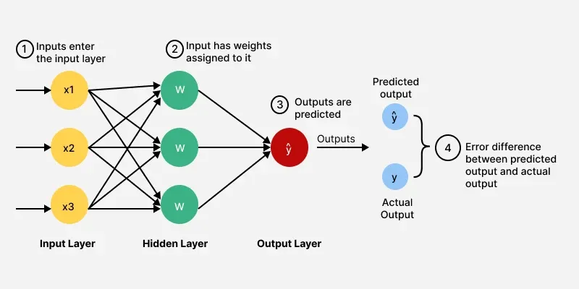

CNN Layer Flow
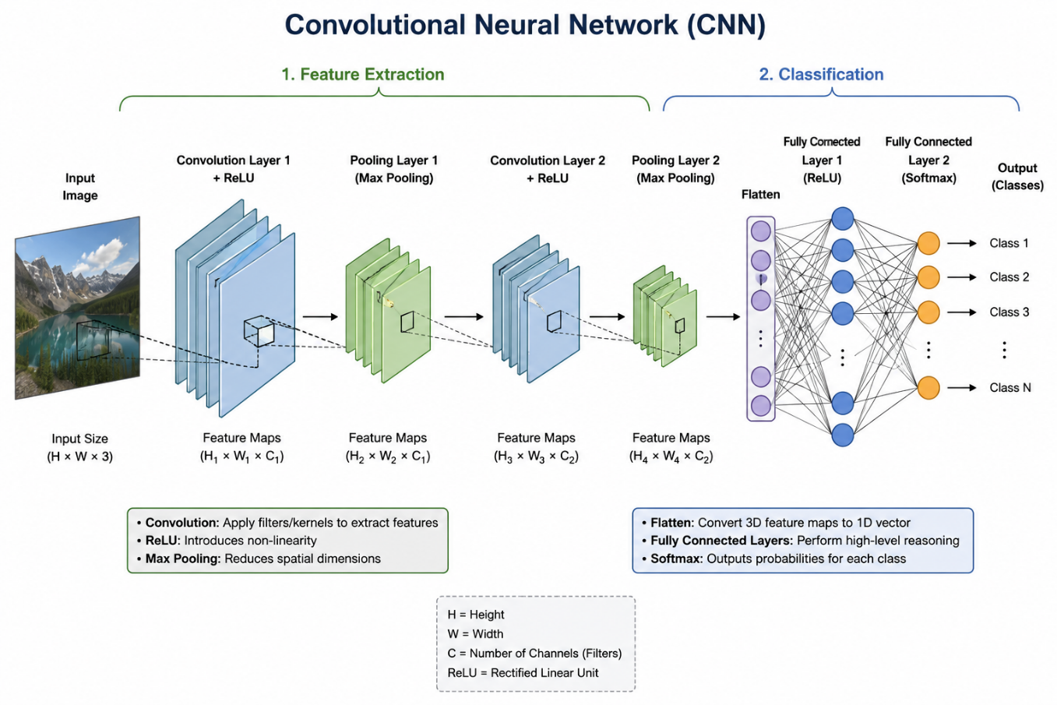

RNN Sequence Flow
